
Insert Organisation Name – [Date]
Vision: (Insert your vision statement here)

CEO Report

Guidance Note to Directors:
If you believe any items below require Board discussion, please contact the Chair at least 48 hours prior to the scheduled meeting.
Guidance Note for CEO:
Any items for decision or discussion should have a separate Board report. This CEOs report should be no more than 2 pages. The primary purpose of this Report is to provide directors with a concise, strategic overview of organisational performance, key developments, risks, and priorities
Agenda Item X | CEO Report | Noting
Presenter/Author: | John Peterson
Recommendation: | That the Board notes the CEO report
Attachments: | Nil

Attestation: Since the last Board meeting (Date), we’ve had:
- No notifiable incidents with regards to privacy breaches and data loss
- No notifiable incidents with regards to health and safety
- Not aware of any cyber breaches or cyber incidents
- No whistleblower escalations
- No sexual harassment or misconduct (Allegations)
- All liabilities are up to date for staff tax payments, superannuation contributions and portable long service leave (if applicable)

Key Metrics | Strategic initiatives | On track
Key Metrics | Operational Plan | On track
Key Metrics | 2025 Budget | In motion
Key Metrics | HR Plan | Attention needed
Key Decisions / Discussions  for this meeting  Strategic implications | Refer to agenda item 5.3 seeking Director approval for xxxxx

Current and emerging issues
Guidance note for CEO: For major issues, a separate Director briefing is required
Planning is underway for the introduction of a new program in 202X. Engagement has commenced with government bodies, local representatives, and staff to inform planning, identify potential challenges, and explore opportunities.
Recent discussions with senior government officials covered the program’s implementation, workforce needs, and the long-term sustainability of relevant service models. Officials acknowledged current challenges and expressed commitment to finding solutions.
A new body is considering establishing a service facility in a regional community. Demographic data suggests the area may not support multiple services, and decisions about the future service mix will be made collaboratively with relevant stakeholders.

Compliance and reporting (External)
1. Reportable Incidents and compliance checking
Overview | The two incidents reported in the May CEO report are still under investigation by the Authority with no official findings or conditions issued. We expect that we will receive communication in the coming weeks.  There was one reportable incident in July
Intended Outcome | Board notes the compliance report

Human Resources Update
2. Workforce context – Strategic implications
Overview | Recruitment for the year is progressing well, with all services currently meeting required staffing ratios. Additional recruitment efforts are underway to fill several above-ratio positions and strengthen the casual relief pool ahead of the winter illness season.  In February, a group of neighbouring local councils launched a joint workforce plan. The strategies and actions outlined in the plan are designed to support regional recruitment and staff retention initiatives.
Intended Outcome | Board notes the HR update

Risk Management
3. Key Risk monitoring: Critical Risks and emerging risks
Overview and Opportunities |  | No change to critical risks, emerging risk is use of AI by staff to develop treatment plans. Board discussion paper will be presented at next Board meeting
Intended Outcome |  | Board notes risk report
3.1 OH&S (Incident, work cover claim, counselling, work performance)
Overview |  | No change
Intended Outcome |  | Board notes OH&S report

Stakeholders and partnerships
4. Changes to stakeholder relationships: Strategic Implications
Overview | A local council has appointed a new Community Services Manager after an extended period without finding a suitable candidate. I have begun engaging with them to facilitate discussions on building leases and the upcoming reforms scheduled to commence in 202X
Intended Outcome | Board notes stakeholder and partnership report

Organisational Culture
5. Culture report
Overview | Organisation’s Values in Action  The first leadership team meeting for the year will be held in mid-August.  Outcomes from the recent all-staff organisational day were included in the June management report.  The annual employee engagement survey is scheduled for December.  No staff recognition awards have been issued to date this year.  An update on the employee engagement action plan will be included in the December governance report.
Intended Outcome | Board notes the culture report




Appendix 1
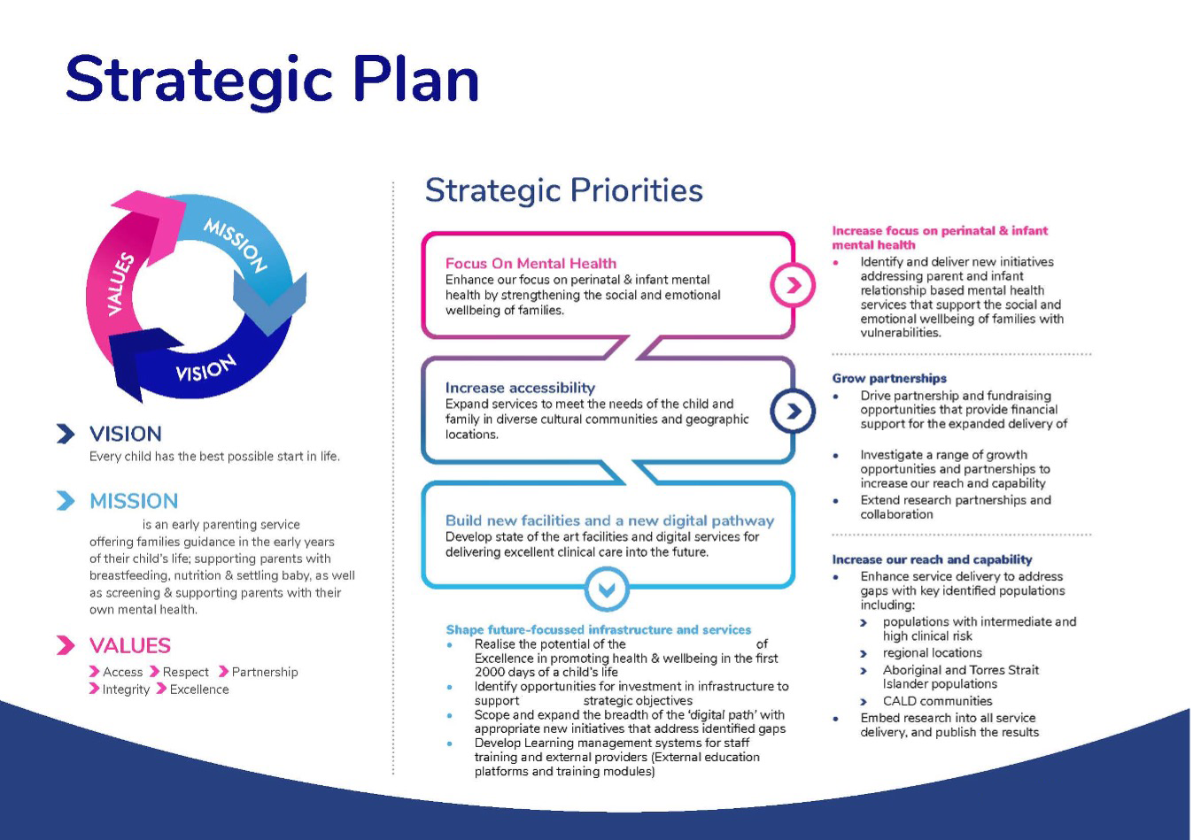
Strategic Priorities and Outcome Measures
Insert Strategy on a Page here

